EXPERIMENT 10
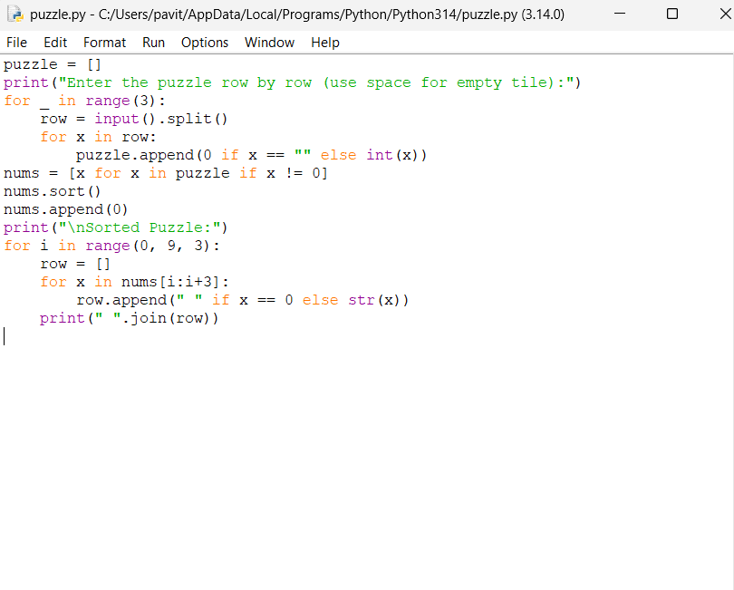
OUTPUT
